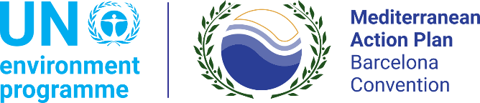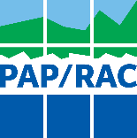

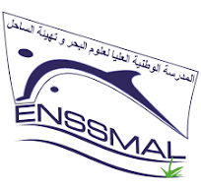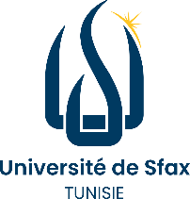

CALL FOR APPLICATIONS
MedOpen Online Training Course on Maritime Spatial Planning (MSP)
2026/2027 SESSION

Learn across disciplines, connect Mediterranean perspectives and contribute to sustainable coastal and marine futures.

REGIONAL PARTNERS
Priority Actions Programme Regional Activity Centre (PAP/RAC), under UNEP/MAP; University of Sfax, Tunisia; National Higher School of Marine Sciences and Coastal Management (ENSSMAL), Algeria; and the University of Tripoli, Libya.

BACKGROUND
The University of Sfax, through its Faculty of Sciences, is pleased to invite applications for the MedOpen online training course on Maritime Spatial Planning. The course is organised within a regional cooperation framework involving Algeria, Tunisia and Libya, with the support of PAP/RAC under UNEP/MAP.

The training will develop students’ knowledge and practical understanding of integrated approaches to the planning and sustainable management of coastal and marine areas. It will also provide an opportunity to exchange experiences and perspectives from across the Mediterranean region.

WHAT WILL YOU LEARN?
• Understand the principles, objectives and stages of Maritime Spatial Planning;
• Explore the links between MSP and Integrated Coastal Zone Management;
• Analyse land–sea interactions and the articulation of terrestrial and marine planning;
• Examine climate change, coastal risks and adaptation in MSP;
• Discover spatial data, GIS and technology-based planning approaches;
• Apply participatory, ecosystem-based and nature-based approaches;
• Discuss marine conservation, governance and maritime foresight.

WHO CAN APPLY?
The call is open to students enrolled in a Master 2 programme or a higher-level programme at the University of Sfax, ENSSMAL or the University of Tripoli, particularly in:
• Marine and environmental sciences;
• Ecology, biology and related disciplines;
• Geography, spatial planning and coastal management;
• Maritime law and environmental governance;
• Any other field related to coastal and marine space management.

No previous specialisation in MSP is required. Applicants should have sufficient English proficiency (B1) to participate in the online sessions.

TRAINING FORMAT AND COMMITMENT
• Online training course;
• One two-hour session every Wednesday;
• Training period: October–23 December 2026;
• Schedule: 19:00 – 21:00;
• Approximately two hours of individual work per week;
• Working language: English;
• Up to 10 places are available for students of the University of Sfax;
• A certificate of participation will be awarded to students who complete the programme and meet the attendance and assessment requirements communicated at the start of the course..

Active participation is expected. Participants are requested to use their camera whenever technically possible. Reasonable exceptions may be accepted in case of connectivity problems, power cuts or force majeure.

APPLICATION DOCUMENTS
Applicants should submit:
• A curriculum vitae;
• A certificate of enrolment;
• A motivation letter of maximum one page;
• Official proof of English language proficiency at least level B1

The motivation letter should explain the applicant’s interest in MSP, the relevance of the course to their academic or professional plans, and their availability to attend all sessions and complete the associated individual work.

SELECTION CRITERIA
Applications will be assessed according to academic level, motivation, relevance of the applicant’s background, availability and language skills. Particular attention will be given to disciplinary diversity, balanced representation among partner universities and gender balance.

APPLICATION TIMETABLE
• Submission of applications: 09 – 22 October 2026;
• Selection of participants: 23 October 2026
• Announcement of results: 26 October 2026;
• Start of the course: 28 October 2026;

HOW TO APPLY?
Please send your CV and motivation letter to both of the following contacts:

Véronique Evers – PAP/RAC: Veronique.evers@paprac.org
Lassad Neifar – University of Sfax: lassad.neifar@fss.usf.tn

Subject line: Application — MedOpen MSP Training Course 2026/2027 — Full Name
Deadline: 22 October 2026 at midnight

For further information: Véronique Evers, Veronique.evers@paprac.org

